导学案
课程基本信息
学科 | 初中英语 | 年级 | 九年级 |  | 学期 | 春季
课题 | 中考一轮话题复习之 Activity Invitation
学生信息
姓名 | 学校 | 班级 | 学号
学习目标
1. 谈论丰富多彩的活动。
2. 学会写邀请函和回复邀请函，包括接受邀请和拒绝邀请。
课前热身
熟读教材与“活动与邀请”相关的单元内容，积累相关表达。
教材内容：
七年级上: Unit 8 When is your birthday?
八年级上：Unit 9 Can you come to my party?
八年级上：Unit 10 If you go to the party, you’ll have a great time.
课上学习任务
- Watch a video and fill in the blanks.  - Read the invitation and choose the correct answers.    ( )1．This invitation is for ________.  A．Audrey’s birthday  B．the opening of Audrey’s cafe  C．a family trip to New York  ( )2．Which color can guests wear?  A．Green. B．Blue. C．Black.  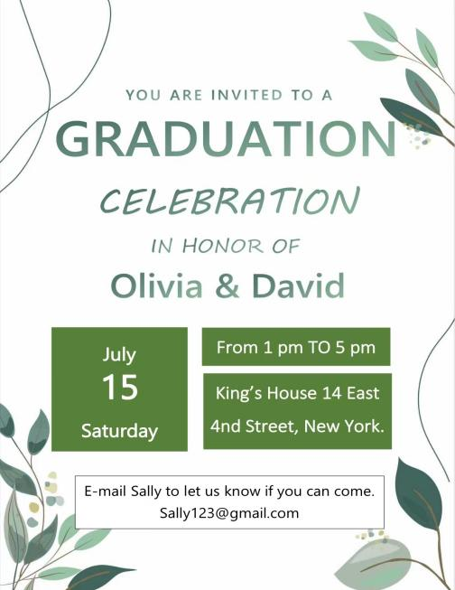  ( )3. When is the proper time to get to the celebration?  A. At 2 pm on July 16th.  B. At 5 pm on July 15th.  C. At 1 pm on July 15th.  ( )4. How can you reply to Sally?  A. By sending a post card.  B. By making a phone call.  C. By sending an email.  III. Useful expressions.  Useful expressions to talk about events:  1. We're planning a ...  2. I would like to invite you to ...  3. Can / Will you come to ...  4. Please join us for ...  5. We are happy to invite you to ...  6. You’re invited to ...  Useful expressions to tell when and where:  1. We’re planning a ... at my house this Saturday / next Monday evening.  2. The ... will be at nine on the morning of Wednesday, January 8th.  3. We’re going to have a ... at + 时间点 + on Center Street.  4. It will start at ... + 时间  5. The ... will from 1 pm to 5 pm.  Useful expressions to make requests:  1.Firstly, in order to ..., you’re expected to ...  2.To achieve better performance, you'd better ...  3. We’ll be very happy if you ...  Useful expressions about replies and best wishes:  1. Please reply to me by + 时间.  2. Please let me know if you can come to the party.  3. I look forward to meeting you.  4. Can’t wait to see you all!  5. Hope all of you have a great time!  Let’s practice! Make an invitation.  假设你是李华, 下周一是你的生日，你想邀请你的好朋友Peter来参加你的生日派对。请根据表格内容给他写一封邀请信, 词数80左右。  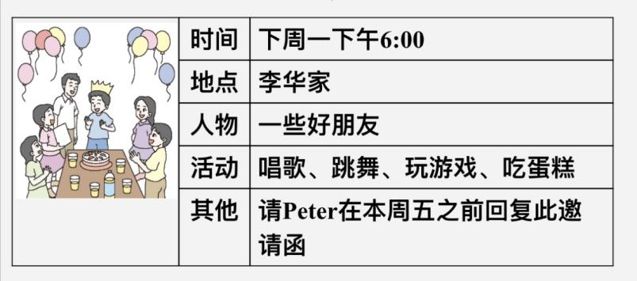  写作结构  Dear ________,  I would like to invite you to ...  My birthday is at ... on ...  My parents will have a birthday party for me ….  We will ... together. At the party, we can ... We’ll enjoy ...  Of course, we will also eat a big birthday cake.  I look forward to seeing you./……  Hope you can make it.  Li Hua  范文  Dear Peter，  I’d like to invite you to my birthday party. My birthday is next Monday. My parents will have a birthday party for me. The party will begin at 6:00 p.m. in my house. It will be a lot of fun. Some of my good friends are coming. We will sing, dance and play games together. At the party, we can enjoy all kinds of food as well as drinks. Of course, we will also eat a big birthday cake. It’s a chocolate cake, your favorite. Come and join us. You will have a good time.  I’m looking forward to seeing you at the party. Please reply to this invitation by this Friday.  Yours，  Li Hua  Let’s practice! Accept an invitation.  李华邀请 Peter 参加他下周一的生日宴会，Peter 刚好有空，也非常高兴参加聚会，对邀请表示感激和欣慰。  写作结构  Dear _________,  Thanks for asking / inviting me.  What a great idea!/That sounds good.  I’m really excited to get your invitation.  I can’t wait to go to your party.  I would like to help with …  I can/will …  I look forward to the party./See you then.  ______________  范文  Dear Li Hua,  Thank you very much for your invitation. What a great idea! It will be great pleasure for me to join your party this Monday. I will arrive at your home before six.  I look forward to meeting you soon. Thank you for thinking of me.  Yours,  Peter  Let’s practice! Refuse an invitation.  李华邀请Amy 参加他下周一的生日宴会，但Amy的父母出差要到下个月回来，奶奶又卧病在床，需要人照顾。再说英语考试即将来临，因此，无法前去参加生日宴会。Amy感到很抱歉，只好写信辞谢。  写作结构  Dear _________,  Thanks for asking / inviting me.  I’m afraid I can’t come. / I’m sorry. I’m not available that day.  I have to prepare for my test.  My grandma is ill, and I have to look after her. ...  I hope you have a good time.  ______________  范文  Dear Li Hua,  Thank you very much for inviting me to your birthday party. I’d love to  go but I can’t. My parents are out on business. They are coming back  next month. And now I have to take care of my grandma because she  is ill in bed. And I also need to study for my coming English exam.  I’m very sorry because I can’t go to your party. Thank you for asking  me. I hope you can have a good time.Can I visit you another time? Best wishes.  Yours,  Amy |  |  |  | Your notes
  send
  reply to
  forward
  read
  First, I the e-mail.
  Second, I the e-mail.
  Third, I the e-mail.
  Fourth, I the e-mail.

